# Analysis of Alternative Configurations

The analysis began by creating summary data from the individual alternative configurations run in MANA. This data was organized into two main summary tables, one capturing blue force troop loss and one for blue force vehicle loss. The reason for the separation was to ensure that we could analyze the effects on loss ratio while preserving the proper attribution to the platform on which configurations were made. Highlighted cells indicate the platforms affected by each alternative configuration (e.g., the EM Gun was implemented on the MBT).

|  |  |  |  |  |  |
| --- | --- | --- | --- | --- | --- |
| **Average Troop Loss By Platform, By Configuration** | | | | | |
|  | **IFV** | **MBT** | **Infantry** | **Helo** | **Loss Ratio** |
| Baseline | 6.857142857 | 7.085714286 | 14.37142857 | 2.228571429 | 0.477232143 |
| STARLite base | 4.714285714 | 3.771428571 | 12.74285714 | 3.6 | 0.387946429 |
| STARLite>Weight | 4.714285714 | 5.714285714 | 12.74285714 | 3.771428571 | 0.420982143 |
| EM Gun | 5.914285714 | 1.485714286 | 16.88571429 | 2.285714286 | 0.415178571 |
| Bradley 105 | 4.885714286 | 5.6 | 7.942857143 | 2.057142857 | 0.320089286 |
| Infrared | 4.628571429 | 6.171428571 | 12.91428571 | 2.285714286 | 0.40625 |
| Composite Armor | 0.085714286 | 5.485714286 | 1.142857143 | 1.942857143 | 0.135267857 |

The first table omits UAV data, as that platform loss never directly results in casualties. Similarly, the second table omits infantry due to a lack of associated vehicle. No configurations were made to the helo although it is included in both summary tables.

|  |  |  |  |  |  |
| --- | --- | --- | --- | --- | --- |
| **Average Vehicle Loss By Platform, By Configuration** | | | | | |
|  | **IFV** | **MBT** | **UAV** | **Helo** | **Loss Ratio** |
| Baseline | 2.285714286 | 1.771428571 | 0.2 | 1.114285714 | 0.477232143 |
| STARLite base | 1.571428571 | 0.942857143 | 0.171428571 | 1.8 | 0.387946429 |
| STARLite>Weight | 1.571428571 | 1.428571429 | 0.085714286 | 1.885714286 | 0.420982143 |
| EM Gun | 1.971428571 | 0.371428571 | 0.257142857 | 1.142857143 | 0.415178571 |
| Bradley 105 | 1.628571429 | 1.4 | 0.228571429 | 1.028571429 | 0.320089286 |
| Infrared | 1.542857143 | 1.542857143 | 0.142857143 | 1.142857143 | 0.40625 |
| Composite Armor | 0.028571429 | 1.371428571 | 0.571428571 | 0.971428571 | 0.135267857 |

So the analysis continued by studying the summary data and comparing each of the alternative configurations to the baseline, individually, in order to arrive at an initial view on gross effectiveness. While this provided us with a broad view of the effectiveness of the changes, we wanted to understand more about how the changes influenced the outcome.

The next task was to roll up the summary data, collapsing it on each platform. Since the alternative configurations were made to the platforms and not individual vehicles, the summary results were most useful when considered similarly. Viewing the data this useful in seeing the contributions of the platforms to the overall effect on loss ratio for a given configuration. Individual factors were also explored by comparing summary data by platform, across the configurations, giving us cross sectional views into how various changes on a platform affect the outcome. Results are shown in the following figures.

Then analysis was performed to determine how closely correlated troop loss was to vehicle kill for each platform. As expected, we found these to be tightly coupled. The interesting finding, though, was that some configurations had a greater effect on loss to infantry squads, which seemed to indicate a greater overall effect on force protection.

The infantry only accounts for Infantry Squads and does not take into account infantry loss due directly to vehicle kill which is what makes this second-order effect interesting.

Separation of the analysis of infantry loss and vehicle kills also allowed an investigation of patterns from one set of data to the other. Specifically, the correlation between infantry loss across all squads and vehicle kills reinforced what we thought we knew about force protection, that they would go proportionally.

**Difference: Inf. Loss-Veh. Kill**

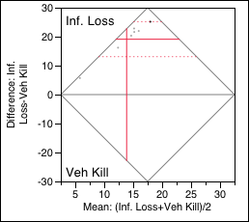

|  |  |  |  |  |
| --- | --- | --- | --- | --- |
| **Inf. Loss** | 23.4327 |  | **t-Ratio** | 7.767784 |
| **Veh Kill** | 4.3102 |  | **DF** | 6 |
| **Mean Difference** | 19.1224 |  | **Prob > |t|** | 0.0002* |
| **Std Error** | 2.46176 |  | **Prob > t** | 0.0001* |
| **Upper 95%** | 25.1462 |  | **Prob < t** | 0.9999 |
| **Lower 95%** | 13.0987 |  |  |  |
| **N** | 7 |  |  |  |
| **Correlation** | 0.84149 |  |  |  |

As you might expect, the loss ratio (calculated as infantry killed / total infantry) in perfectly correlated with Infantry Loss. The Matched Pairs analysis for vehicle kills to loss ratio looks exactly like the table above. The data show that with only the exception of the EM Gun, the number of vehicle kills predicts infantry loss. This is available visually in the following table.

A more thorough analysis yields the following findings, which corroborate and quantify our initial understanding. The following looks at loss ration as a function of vehicle kills. As stated previously, loss ratio and infantry kills are perfectly correlated and, therefore, not as interesting.

**Actual by Predicted Plot**

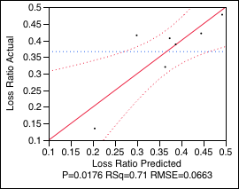

**Summary of Fit**

|  |  |
| --- | --- |
| RSquare | 0.708111 |
| RSquare Adj | 0.649734 |
| Root Mean Square Error | 0.066284 |
| Mean of Response | 0.366135 |
| Observations (or Sum Wgts) | 7 |

**Analysis of Variance**

| **Source** | **DF** | **Sum of Squares** | **Mean Square** | **F Ratio** |
| --- | --- | --- | --- | --- |
| Model | 1 | 0.05329307 | 0.053293 | 12.1298 |
| Error | 5 | 0.02196779 | 0.004394 | **Prob > F** |
| C. Total | 6 | 0.07526085 |  | 0.0176* |

Looking at the individual squad effects, we notice that the two types of squads that have the greatest effect on loss ratio are Infantry and IFV.

**Scatterplot Matrix**

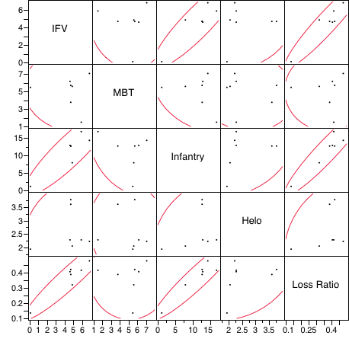

While the scatter plot data produced a convincing visual overview of the correlations, a more in-depth analysis yielded a better understanding of both Infantry and IFV, which turn out to be fairly good predictors of loss ratio. This analysis is based on total infantry loss, both mounted and dismounted.

Consequently, we would assume that improvements to the IFV platform would tend toward the greatest improvements in loss ratio. This is not surprising in that the IFV generally contains the highest concentrations of mounted infantry. However, let us remember that there were nontrivial second-order effects on dismounted infantry, as well, due to improvements in the IFV.

**Actual by Predicted Plot**

**Infantry & IFV vs. Loss Ratio**

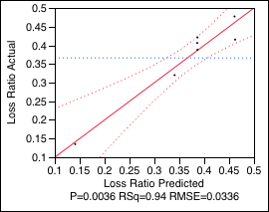

**Summary of Fit**

|  |  |
| --- | --- |
| RSquare | 0.939886 |
| RSquare Adj | 0.909829 |
| Root Mean Square Error | 0.033631 |
| Mean of Response | 0.366135 |
| Observations (or Sum Wgts) | 7 |

**Analysis of Variance**

| **Source** | **DF** | **Sum of Squares** | **Mean Square** | **F Ratio** |
| --- | --- | --- | --- | --- |
| Model | 2 | 0.07073662 | 0.035368 | 31.2701 |
| Error | 4 | 0.00452423 | 0.001131 | **Prob > F** |
| C. Total | 6 | 0.07526085 |  | 0.0036* |

Supporting the above findings, the following is the Fit Model for IFV, alone, to loss ratio. This time the analysis reflects only platform kills and those infantry losses resulting directly from the platform kill. This highlights the predictive value of IFV to loss ratio and reasserts the importance that improvements to the IFV have to force protection.

**Regression Plot**

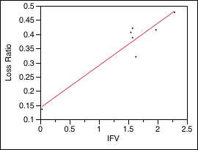

**Summary of Fit**

|  |  |
| --- | --- |
| RSquare | 0.892955 |
| RSquare Adj | 0.871546 |
| Root Mean Square Error | 0.040141 |
| Mean of Response | 0.366135 |
| Observations (or Sum Wgts) | 7 |

**Analysis of Variance**

| **Source** | **DF** | **Sum of Squares** | **Mean Square** | **F Ratio** |
| --- | --- | --- | --- | --- |
| Model | 1 | 0.06720455 | 0.067205 | 41.7093 |
| Error | 5 | 0.00805631 | 0.001611 | **Prob > F** |
| C. Total | 6 | 0.07526085 |  | 0.0013* |